Study Buddies

Team Ant
Project Manager: Cyril Agbewali
Developers: Andrew Bobay, Kelvin Nana Gyebi, Zachary Bailey, Ryan Bowley
Designers: Alexander Higgins, Ryan Hallett

Problem Statement
Students often struggle to learn how to improve their learning and performance while also lacking a supportive community to help them reflect on their experiences. Reflection groups can provide this support, but organizing productive groups can be difficult and time-consuming for facilitators and students alike.
It is also hard to get enough motivation to try a new practice like reflection groups, for students and even instructors. People have ideas about why reflection groups would not work, based on prior knowledge/experiences or misconceptions about what reflection groups are.
For example, students may be reluctant to seek out reflection groups on their own. At the same time, instructors and other facilitators may struggle to find and match students into groups that work well together.

Reflection groups can be more productive when members share similar experiences, challenges, and perspectives because these similarities can make it easier to empathize, exchange relevant advice, be more vulnerable, and feel comfortable sharing struggles. However, finding these compatible group members can require significant effort from facilitators.

How might we design supportive tools to enable students and instructors to get over the motivation barrier to trying reflection groups, then find and sustain compatible reflection groups, so students can have more beneficial reflection experiences, while requiring less facilitation effort (even when an instructor does not organize groups)?

Problem | Why / Cause | Foothold for solution / way to address the cause
It is hard to get enough motivation to try a new practice like reflection groups, for students and even instructors. | People have ideas about why reflection groups would not work, based on prior knowledge/experiences or misconceptions about what reflection groups are. | Show convincing arguments on how and why reflection groups work, including prior evidence  Explain reflection groups clearly and succinctly to address misconceptions
Forming compatible groups requires time and effort which instructors are not ready to commit to. | Matching on experiences, challenges and schedule is time consuming when done by hand. | Automating the matching using the survey data.
Reflection groups are difficult to sustain without a structure (agenda) | There is no support/accountability after the groups are formed | Provide weekly agenda and drop-in to keep the groups meeting and creating some form of accountability

Prior Solutions

Solution 1: Discord
Discord is one of the most popular apps currently with 656 Million registered users. Discord allows users to create servers (chat threads) and invite any other discord user to it, as well as invite bots which can be any number of publicly available bots or you can program your own with the Discord Developer API. Our apps are similar in the sense they are both social networking apps which accommodate smaller groups and have role management (IE: an instructor role who can manage who is where, and a student role who can only see in a given group).

StudyBuddies will be different as the main purpose behind it is the study group functionality as such it will be built into the app itself as well as to accommodate for study partner matching; comparing to Discord, there is no pair matching algorithm and being built for community rather than separated groups. We want better profile settings, like blacklists, profile tags for interests to better help match users, clear divides between both classes and individual groups, and calendar integration to help schedule and or facilitate time within the group itself.
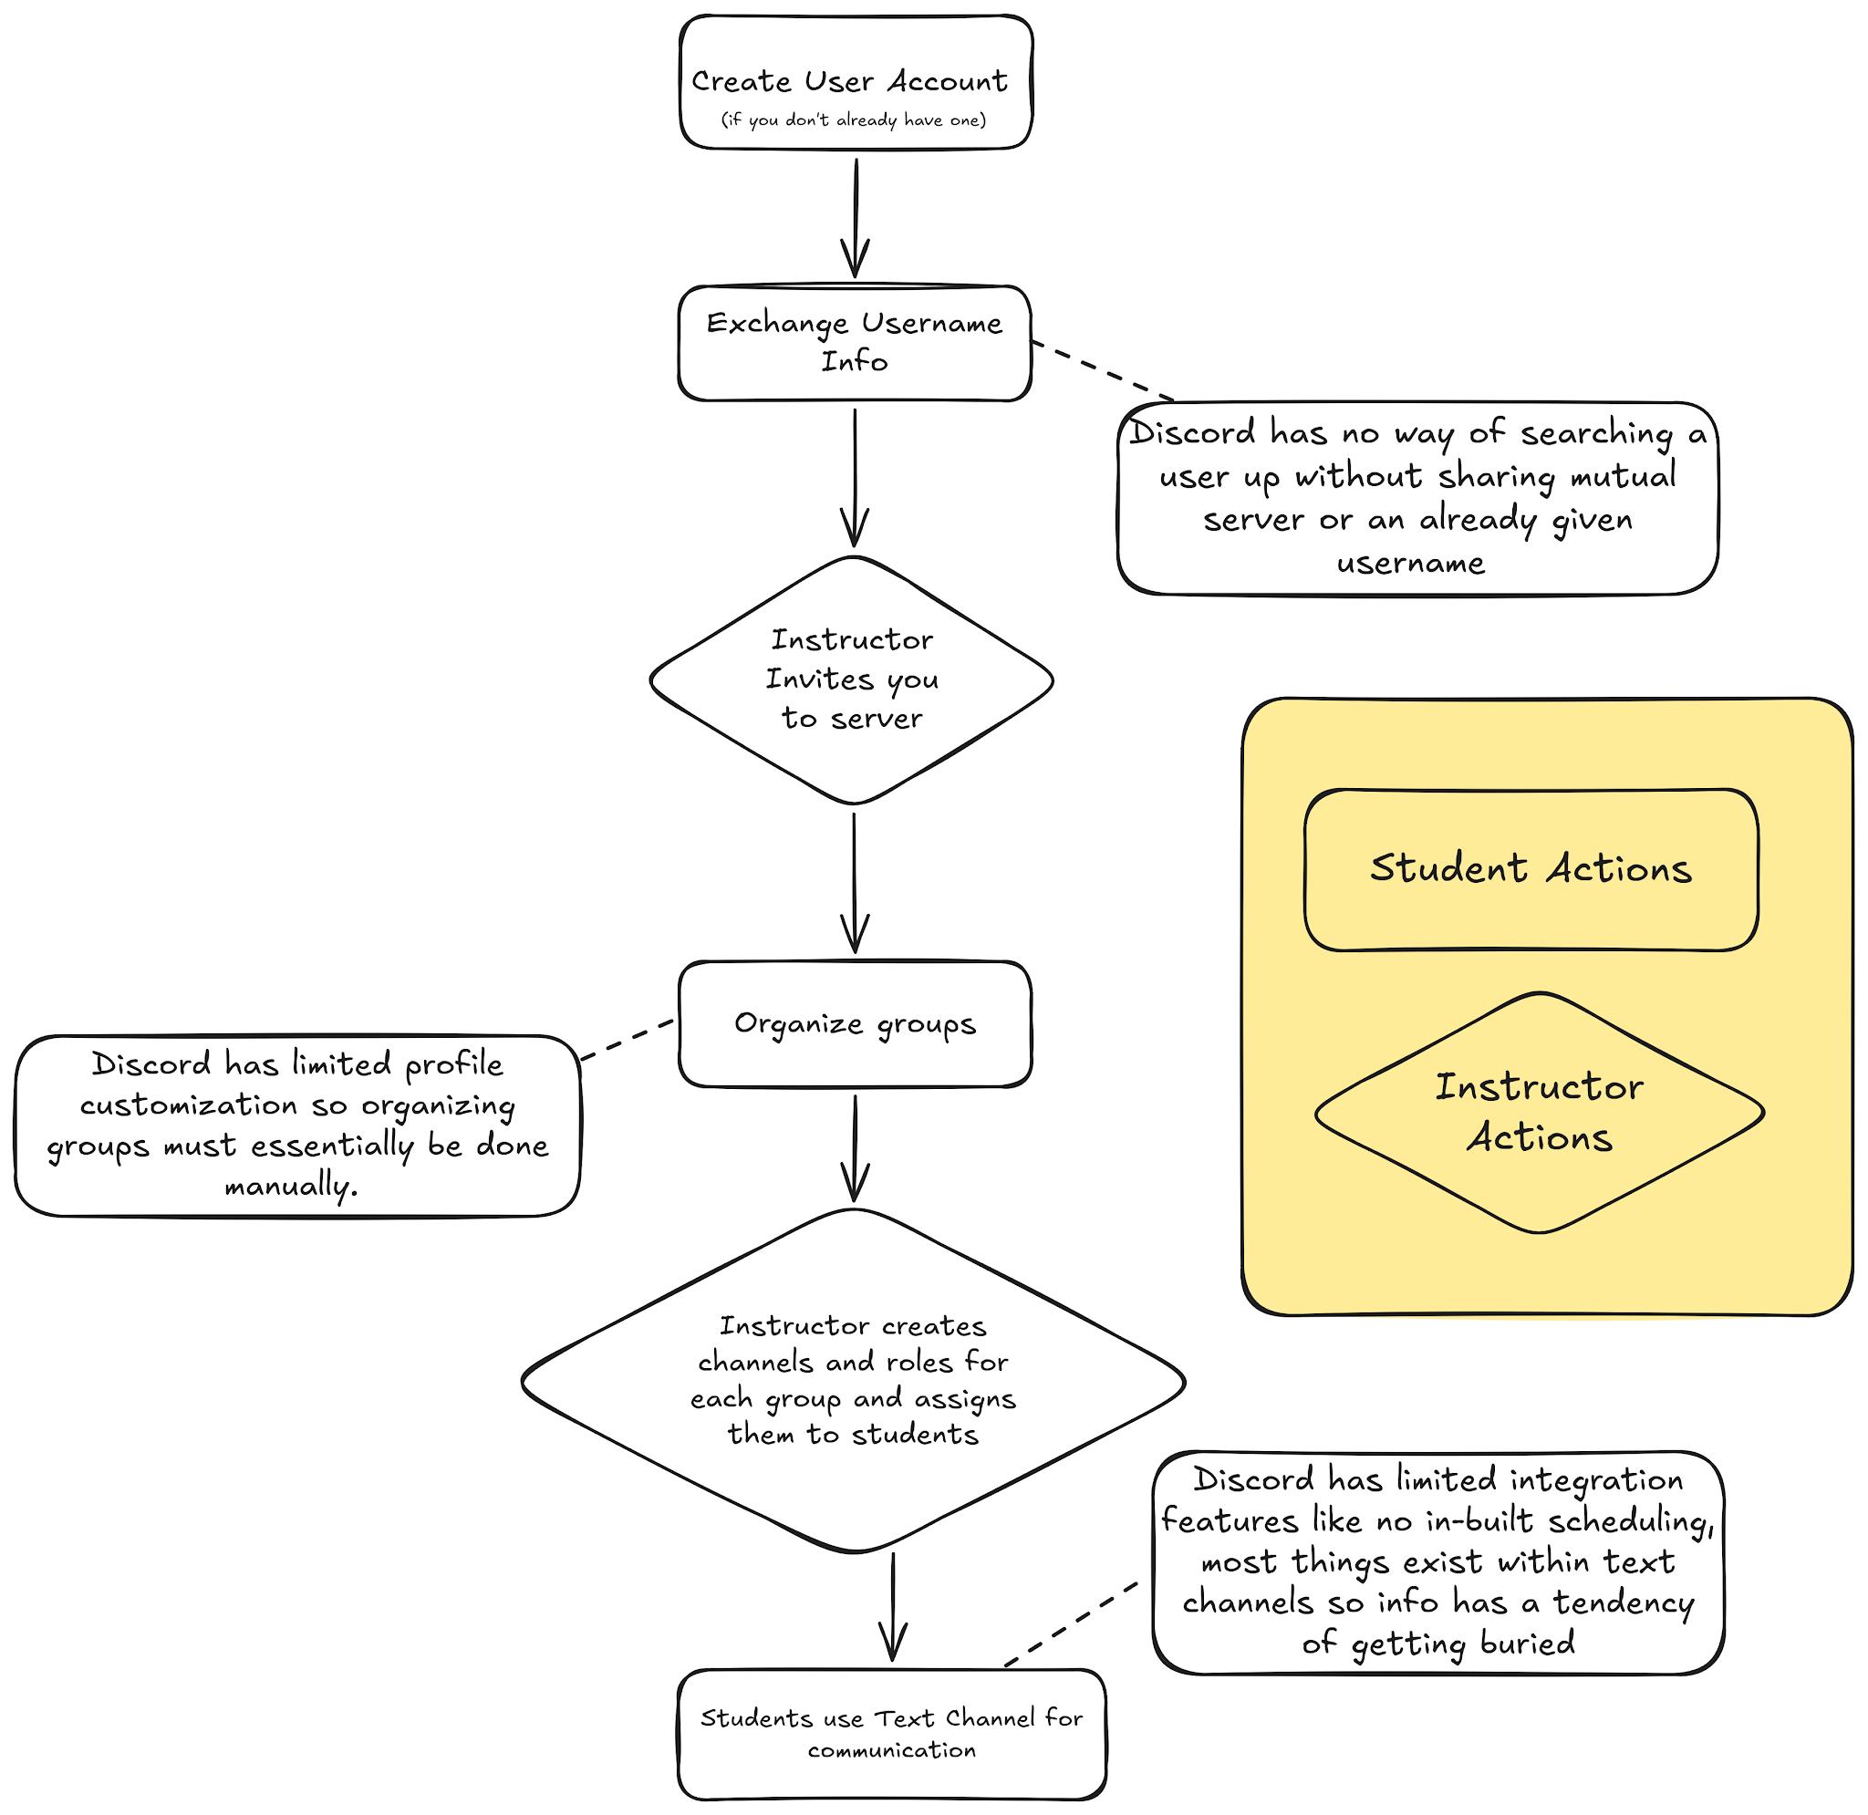

Because the functionality of pairing groups is not built into Discord you either need some very elaborate bot which is typically not very UX friendly or somehow organize groups some other way meaning using Discord does not address a core problem of facilitation effort when it comes to using it in Study Groups

Solution 2: Study Stream
Study Stream is a worldwide studying platform for students to connect and study with people from across the globe. Upon sign up it asks a number of personality questions to recommend others that would be a good match for study partners. It lets users make posts to help find others to study with. Groups allow users to connect privately with multiple users that can chat and start video calls. It also houses a leaderboard that tracks time spent in video calls/focus rooms and a streak of days spent studying in a focus room. These video calls/focus rooms offer an easy solution for users studying together, however, this is a limited feature with only 1 hour of time in a focus room for free. There is a way to buy more hours for a few dollars with a membership option. StudyBuddies shares similarities as they offer an easy way to connect with others that have similar interests, and allow communication in app. They allow the user to have groups that allow text and video chat anytime. Both apps ask the user personality questions so that they can find users with similar answers.

Study Stream is good for a social media take on study groups, however it fails to have an automated sorting system available. The goal of StudyBuddies is to eliminate the instructor manually sorting students into groups without knowing them and students from having to go out and form a group on their own. To find other students in class that have similar interests with you to form reflection groups to grow and foster better learning as well as community. Our app is meant to help facilitate group making, meaning the answers of the personality questions will automatically sort the user into a group for the instructor to approve. will be used to match you with others like minded to you. This is a feature that StudyStream is lacking as users have found others to study with them on their own. Not having groups sorted automatically creates an extra step for the instructor and student. This extra step can be enough to push away users from this solution. StudyStream having a leaderboard can also cause a problem as it can be perceived as competitive. Our App is focused on the ease of creating focus groups with like minded students, it isn’t a competition.
StudyStream Task Flow:
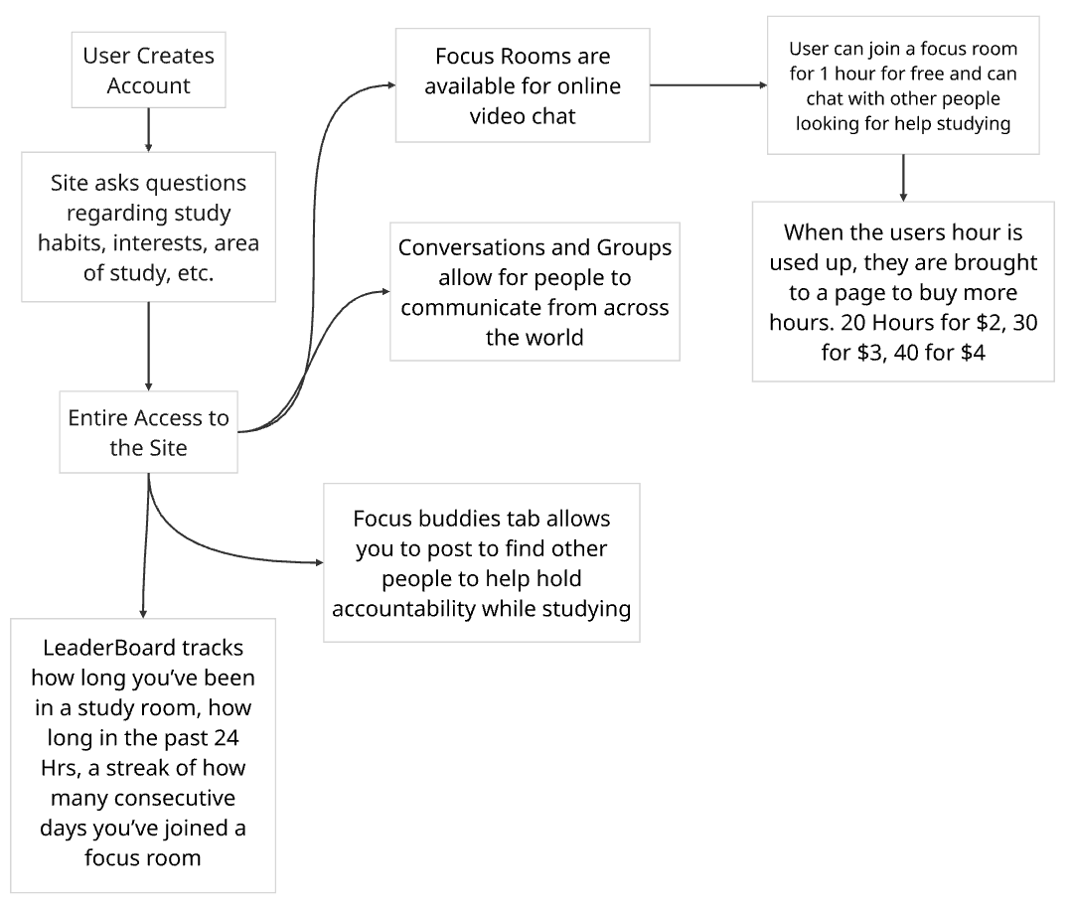

Solution 3: CATME

CATME is a web-based system developed by Purdue University. It was designed to help instructors form student teams through survey data and conduct peer evaluations within academic courses.

Both CATME and Study Buddies are similar in the sense that they both utilize onboarding responses to gather student information such as their study habits and availability. They then employ automated matching algorithms to place students into groups that suit their need and hence reduce the burden on instructors, who would otherwise have to match them manually.

On the flip side, Study Buddies remains unique and differs by offering features that allow users to customize their profiles, integrated calendar and integrated weekly reflection agendas; just to name a few. CATME is strictly an administrative tool that lacks the in-app messaging feature and community features that prompts engagement and helps sustain the group in the long run.

CATME is designed solely for a one-time team creation which is grade-focused in its evaluation. This tends to treat group work as administrative assignments and hence lacks peer interaction. Study Buddies shifts the focus to long-term peer motivation, social connection and empathy. It does so by keeping groups active and accountable through its integrated social tools and meeting structures; for example, post meeting accountability logs and recurring weekly check-ins.

CATME Task Flow Diagram:

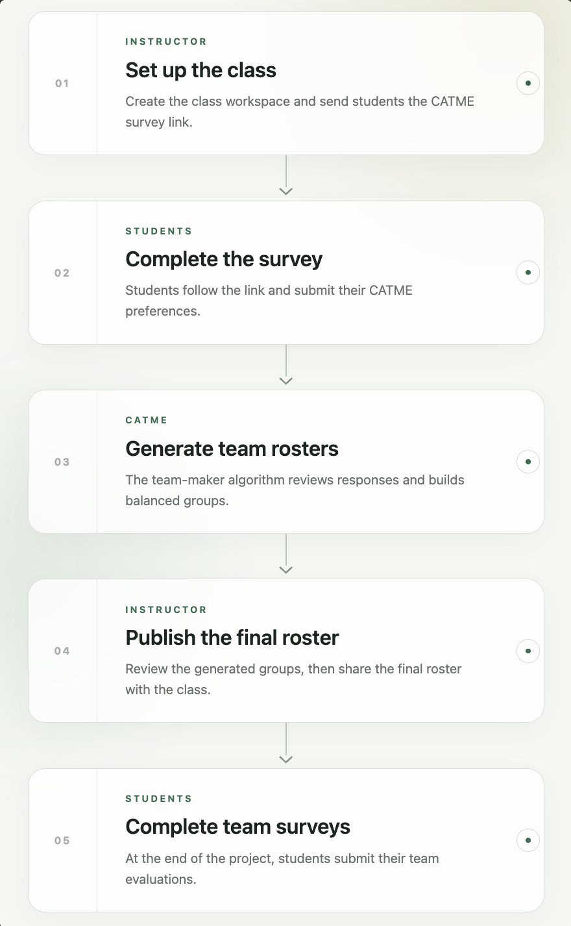

StudyBuddies - Overview

StudyBuddies is an application that will help students and instructors to connect online to form study and reflection groups.

Most students struggle with finding partners to create study or reflection groups in person. StudyBuddies helps with this by providing a platform to do the matching for them. Once signed in, students do a short survey that covers their availability, gender, and other questions that the app will use to match them with similar students and make sure nobody is left out. Once groups are formed and published, students get on a server/group chat where they can communicate and also get feedback.

Users will be able to create profiles that showcase their interests and preferred study methods.
To get into a group, students fill out a short survey about their availability, gender, and whatever else the instructor decides matters to create the reflection groups.

The app then forms the groups in seconds, making sure it creates the groups based on the criteria given by the instructor. Students are placed in groups they are likely to feel comfortable around. Before groups are published, instructors are able to review them and move students.

Updated Task Flow: I used https://lucid.app/
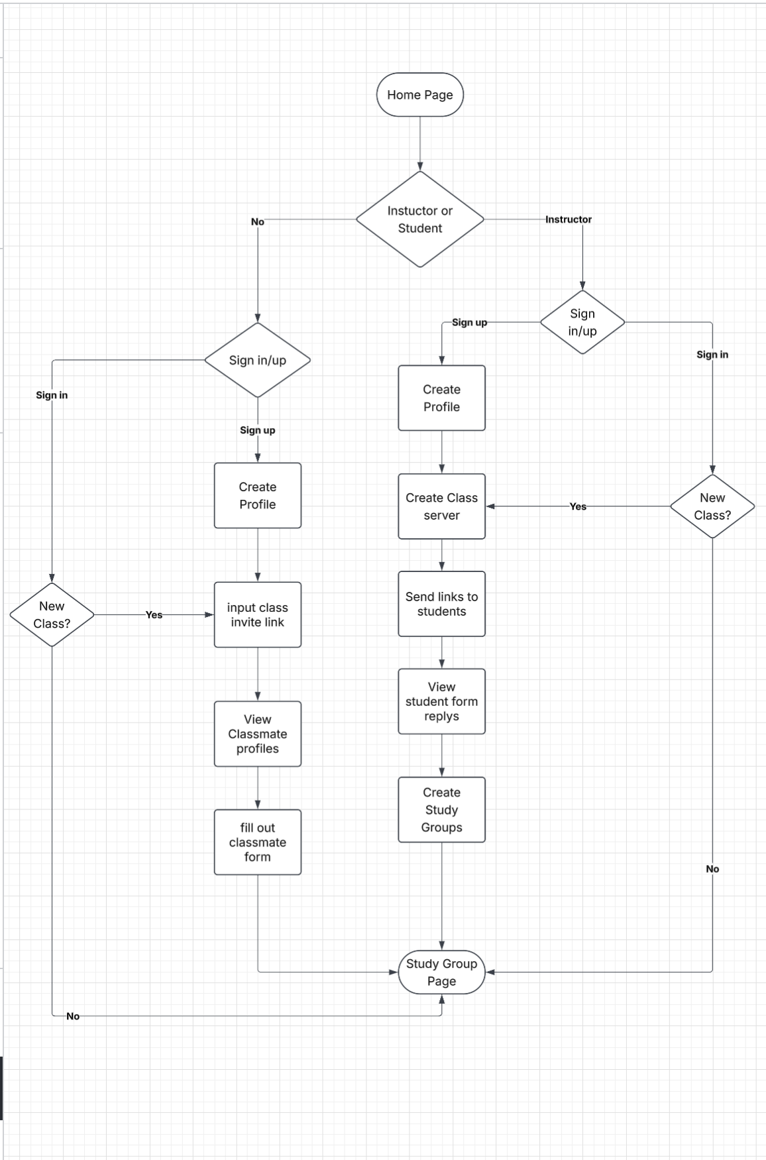
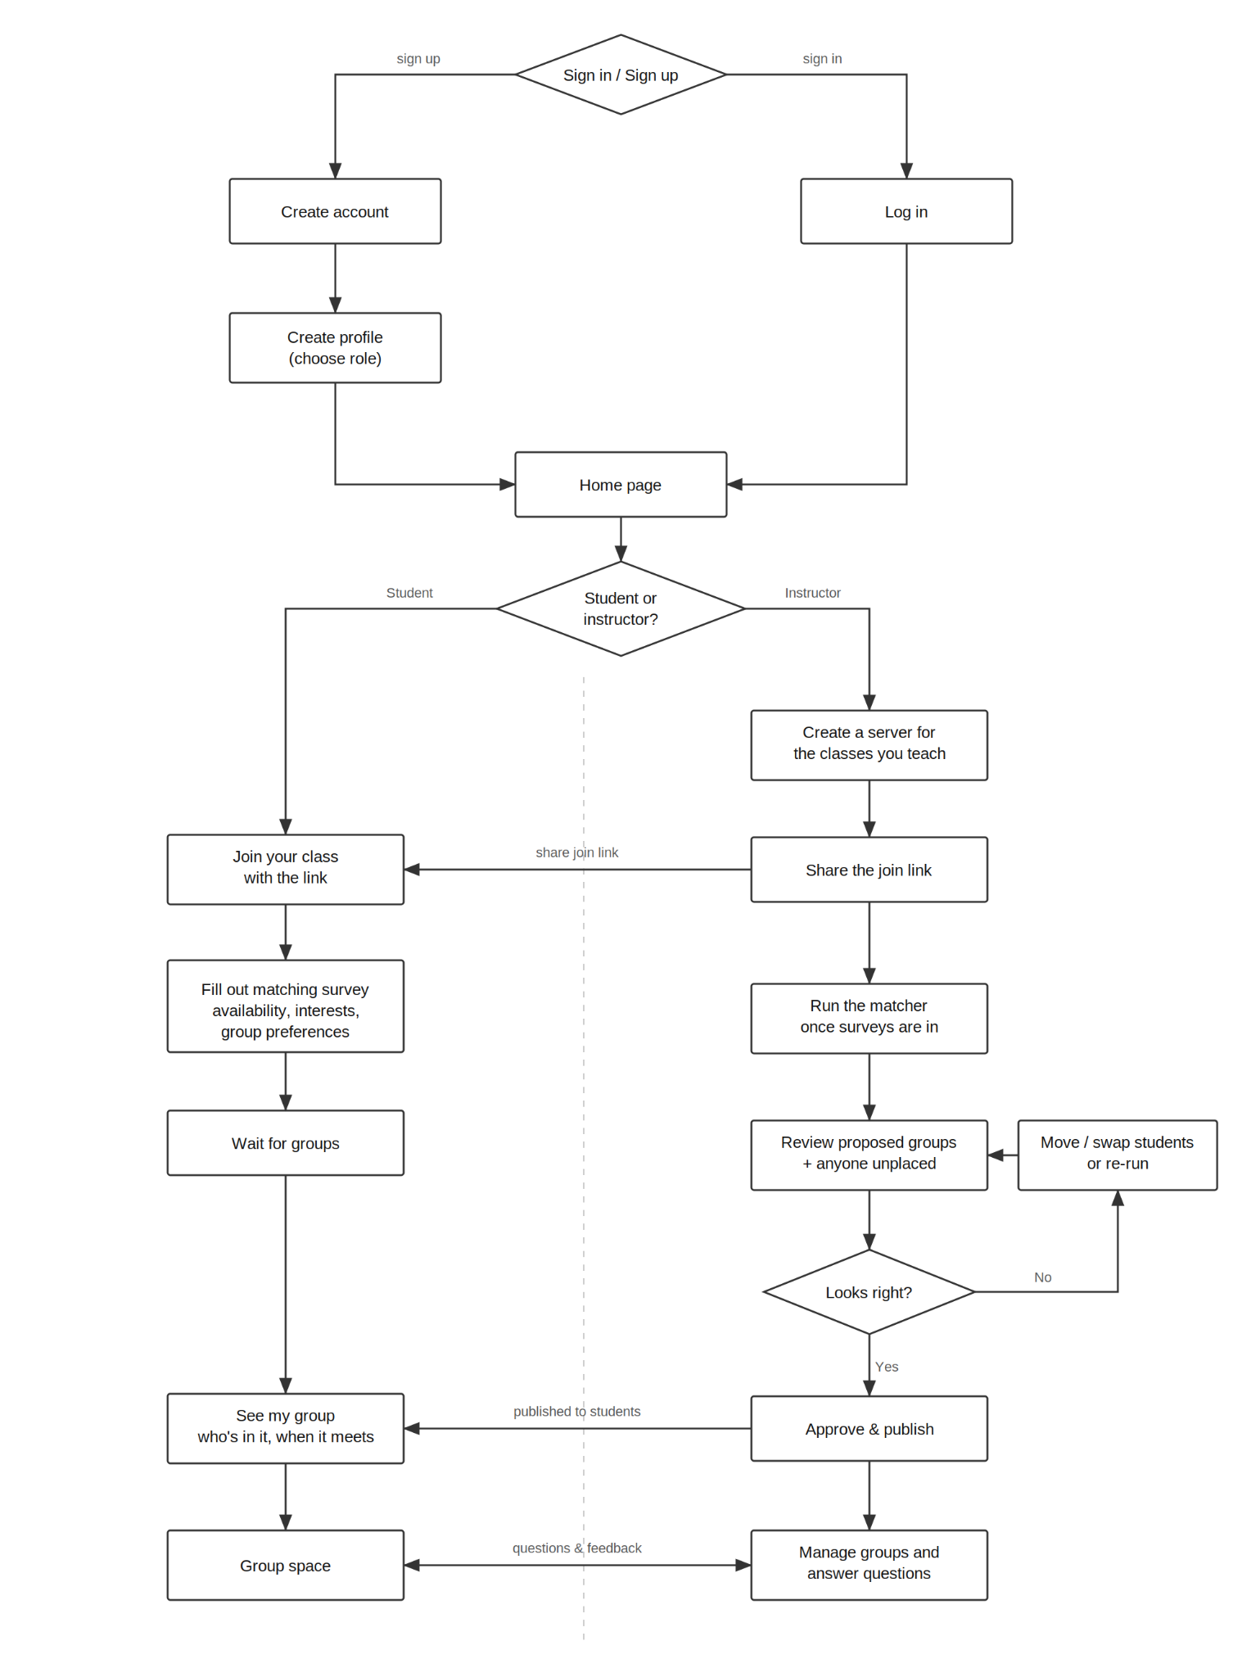

With larger classes, students often know nothing about their peers unless they spoke outside of class. StudyBuddies improves this by having every student make a profile for themselves outlining what courses they take, their interests, and their availability. Once groups are formed, members can view their colleagues' profiles so that there is something that can start the conversation. Whatever a student puts in the matching survey is confidential and not shared with other students.

Study and reflection groups are often made and organized by students, and instructors usually don't have any contact with them. StudyBuddies gives instructors a path to help students with problems. After creating an instructor profile, they are able to create a server for the classes they teach, and students can then join via a link and fill out a survey to specify desired group members or undesired group members. This lets instructors easily create reflection groups, manage them, and also answer any questions that come up.

